**Exercises Module 6:**

**Von Neumann Model and introduction to LC3**

**Exercises:**

1. **We wish to execute a single LC-3 instruction that will subtract the decimal number 25 from register 1 and put the result in register 2. Can we do it, if yes, show how it would be done, if not, explain why**
2. **Write the instruction for following machine code in memory:**

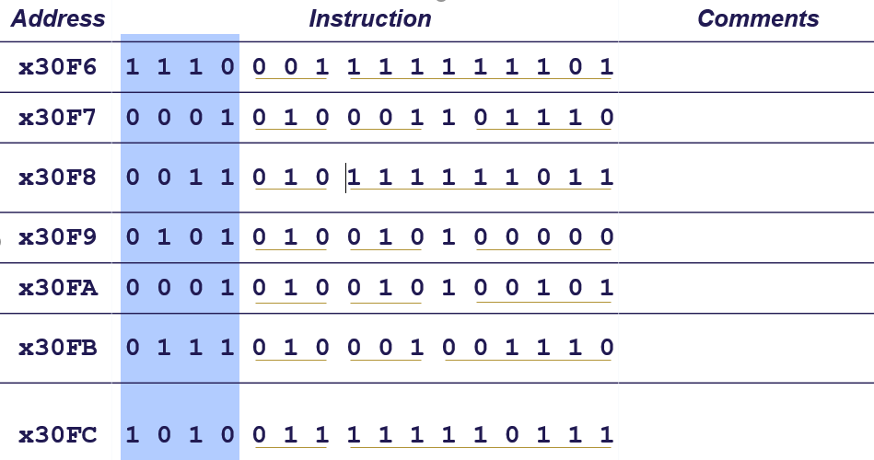

1. **We want to increase the number of registers that we can specify in the LC-3 Add instruction to 32. Do you see any problem with that? Explain.**
2. **An LDR instruction, located at 0x3220, uses R3 as its base register. The value currently in in R3 is 0x4011. What is the largest address that this instruction can load from?**
3. **The LC-3 has no subtract instruction. How could one perform the following operation using only three LC-3 instructions: R1 ← R6 − R2**
4. **How do we OR using LC-3? Prove it**
5. **Compute sum of 12 integers. Numbers start at location x3100. Program starts at location x3000.**
6. **Count the occurrences of a character in a file**

* Program begins at location x3000
* Read character from keyboard
* Load each character from a “file”
* File is a sequence of memory locations
* Starting address of file is stored in the memory location  
  immediately after the program
* If file character equals input character, increment counter
* End of file is indicated by a special ASCII value: EOT (x04)
* At the end, print the number of characters and halt  
  (assume there will be less than 10 occurrences of the character)